

Department of Computer Science

Individual Project – CS3IP16

Predictive Analytics for Film User Ratings

|  |  |
| --- | --- |
| **Student:** | Kane Small |
| **Student Number:** | 23013043 |
| **Supervisor:** | Jonathan Boyle |
| **Submission Date:** | 20th April 2018 |
| **Word Count:** |  |

Abstract

### Here you create a brief summary of the content of your report. Making clear the subject matter, the problem, solution and headline results. An abstract should not normally be longer than about 250 words, and in most cases should be finalised last when the main content of your report is complete.

# Acknowledgements

First and foremost, I would like to express my gratitude toward Jonathan Boyle for his continued support throughout my project’s lifetime and helping to guide the project in the right direction.

Secondly, I would also like to thank my Mother for her wisdom, support and strength throughout this entire year.

Lastly, I would like to thank my friends for assisting me with carrying out testing and providing valuable feedback toward improving my project along the way.

Table of Contents

Acknowledgements i

Glossary of Terms and Abbreviations iv

1 Introduction 0

2 Problem Articulation and Technical Specification 2

2.1 Problem statement 2

2.2 Stakeholders 2

2.3 Technical specification 2

3 Literature Review 5

4 Solution Approach 6

5 Design and Implementation 7

5.2 Data acquisition 7

5.3 Data cleansing/pre-processing 7

5.4 Regression algorithm and predictions 7

5.5 API routing 8

5.6 Front-end design and user experience 8

6 Testing Verification and Validation 11

6.1 Unit testing 11

6.2 Compatibility testing 16

6.3 Usability testing 17

6.4 Regression metrics 17

6.5 Testing limitations 18

7 Discussion 19

7.1 Known issues 19

7.2 Prediction accuracy 22

7.3 Application limitations 23

8 Reflection 24

9 Social, Legal, Health and Safety and Ethical Issues 26

9.1 Social, legal and ethical issues 26

9.2 Health and safety risks 26

10 Conclusion 27

11 Future Improvements 28

11.1 Improving prediction model accuracy 28

11.2 TV show support 28

11.3 Additional trend graphs 28

11.4 External ratings 28

11.5 Updater function 28

11.6 Targeting businesses 29

11.7 Oscar nominees and winners 29

12 References 30

13 Appendices 31

13.1 Appendix 1: Project Initiation Document 31

13.2 Appendix 2: Logbook 31

13.3 Appendix 3: Questionnaire 31

13.4 Appendix 4: Scikit-learn algorithm cheat sheet 31

# Glossary of Terms and Abbreviations

API – Application Programming Interface

CA – Certificate Authority

Clustering – A machine learning problem whereby the outcome is to create groups of values based on their similarities.

Classification – A machine learning problem whereby the outcome is to predict a discrete output, i.e. a class or category.

CSS – Cascading Style Sheets

Data mining – Is the process of finding patterns within data.

DBMS – Database Management System

FTP – File Transfer Protocol

HTML – Hypertext Markup Language

JS – JavaScript

JSON – JavaScript Object Notation

Machine learning – Is the process of building models using data mining techniques, in order to predict future outcomes.

MAE – Mean Absolute Error

Model – In machine learning, a model is the output generated after training a machine learning algorithm with a training dataset. It takes in a predefined set of inputs and produces an output based on these variables.

One-hot encoding – Converts a set of categorical values into separate features, that are all represented by a binary value (0, 1).

ORM – Object-relational Mapping

PCA – Principal Component Analysis

PID – Project Initiation Document

RDP – Remote Desktop Protocol

Regression – A machine learning problem whereby the outcome is to predict a continuous value.

SSH – Secure Shell

Supervised learning – A machine learning category that relies on humans to act as the teacher whereby, we feed in a training dataset that includes the features and target values and from this data an algorithm can learn the relationships between the features and the target values in order to predict target values for previously unseen data.

TMDb – The Movie Database

UoR – University of Reading

UPS – Uninterruptable Power Supply

VFX – Visual Effects

VPN – Virtual Private Network

# Introduction

Machine learning is still in a very primitive state at this point in time but is being utilised a lot more frequently across different industries, from entertainment, to finance, to transportation services and many more (Sas.com, 2018). The process for machine learning models is to formulate patterns and understand the inter-linking features within the dataset being analysed, that can then be used against previously unseen datasets in order to predict values to a certain degree of accuracy. But ultimately, the end goal for using this new technology is to make better decisions without the need for human intervention.

This is where this project comes into play. The application uses machine learning regression algorithm to train a model that can successfully predict rating values for films that have yet to be released, based on the most important key attributes (the features) that influence viewer’s decisions. The main purpose behind building this application is to essentially make it easier for anyone to decide whether to see a film, based solely on a single value. This singular rating percentage is the result of, finding the inter-linking patterns and relationships of the most important film attributes and is ultimately as unbiased as possible by using only factual information.

The project commences by identifying the problem that is trying to be solved, listing the stakeholders that will form the main target audience of the application and more importantly, the main objectives of the project. In order to accomplish these objectives, it is necessary for the project to be split into five separate parts, data acquisition, data cleansing/pre-processing, regression algorithm implementation, API routing and front-end design/user experience. The first phase focuses on acquiring data from a viable source that meets the requirements (i.e. relevant metadata), the next phase transforms the acquired data into a correct format for the input to the algorithm and stores it into the database, the thirds phase implements the regression algorithm and train a model; the fourth phase revolves around building an API that will interface with the database and display data to the front-end and the last phase will concentrate on the user-experience and ease-of-use of the application.

Furthermore, the motivation and reasoning behind undertaking this project is brought to light, followed by the constraints that illustrate potential challenges for the project.

The application must then look next at any existing applications that carry out either the same or similar tasks and see how it can be improved upon, from both a machine learning accuracy and a user-experience perspective. This is accomplished by reviewing existing literature and from the findings, justify an informed solution approach on how best to meet the objectives outlined. The solution approach itself will also aim to cover any tools and technologies utilised throughout the development process in brief.

The design and implementation of the application will be explored in detail, illustrating exactly how the technologies and any libraries aided in the development of the product. The implementation will build all the way to the result of the model, which will be examined in detail as part of the discussion. This will also address the success of the solution, as well as any limitations that have been identified along the way. A reflective piece will lead on from here, bringing to light what the challenges were, what has been carried out well and how the project would be approached differently if attempted a second time.

Any potential social, legal, ethical and health and safety risks of the project are reviewed in short at this point, which will support the continued development and improvement of the application in the future.

Lastly, the report comes to an with a conclusion that quickly restates the main project objectives and discusses whether the solution that has been implemented has in fact met them. Nevertheless, this outcome leads into a list of future improvements that could potentially elevate both the project’s effectiveness and use.

# Problem Articulation and Technical Specification

## Problem statement

The number of variables that determine whether a film will be a high user-rated success has increased dramatically over the years, in-part due to the advancements made within the film industry allowing production companies to offer a wider variety of films to the viewers, specifically in the Visual Effects (VFX) category. So, with this comes the pressure of leaving it to the viewer to determine whether a film is going to be enjoyable based on these attributes. But, a viewer can only use what they already know about an upcoming film such as the genre of the film, or the actors cast, or the trailer and so on and these attributes will simply *influence* their decisions; but will not tell them whether or not this film will result in a decent or meagre film-viewing experience.

This project aims to alleviate that pressure on viewers by taking all of the factual data already present and using it to make accurate predictions on the overall rating of unreleased films, but by taking into account each of the most important film attributes and even finding relationships between them.

## Stakeholders

A total of three stakeholders were identified for this particular project, revealing how they would be affected by or provide assistance in achieving the outcome of the project.

### Developer – Kane Small

The developer, Kane Small, is responsible for advancing the project through all phases of the development lifecycle. This involves making sure that the problem statement outlined in section *3.1* is resolved and this will be accomplished by fulfilling the objectives outlined in section *3.3*. Due to time constraints and other important engagements throughout the year, the developer will also be responsible for maintaining an effective pace through time management and organisation, to ensure that project goals are met on time.

### Project supervisor – Jonathan Boyle

The project supervisor, Jonathan Boyle, is the person who will provide continued support and assistance toward guiding the project in the right direction at all times. This will be accomplished by scheduling weekly and/or bi-weekly meetings whereby a detailed discussion will comprise of the work that has been carried out and any problems encountered since the last meeting ending with a summary of what will be tackled by the next meeting.

### User – Film Viewers

The user of the finished product will be, any film viewer that is uncertain on whether or not to see an upcoming film. They will expect to use a system that is easy-to-view and understand, where the content has been organised in a concise and logical manner but most importantly that the prediction result being displayed is as accurate as possible; as they will be relying on this factor to make their decisions for them.

## Technical specification

The application to be developed will reside on a server that will deliver the content to the internet. There will be two pages, the *main* application page that will display all of the film metadata including the prediction result and a *trends* page that will provide users with updated trend graphs for the data being held.

Utilising the previously created PID, the project must satisfy the objectives outlined. However, the objectives that are listed below have been altered in order to conform to realistic time constraints and developer experience:

**Data acquisition**

* Implement a viable API data source
* Utilise the YouTube API for film trailer acquisition
* Design, build and configure the database to store the film data
* Implement a viable Python framework
* Build the scripts that will perform the data acquisition
* Setup and configure a server to host the scripts
* Create a questionnaire to aid with feature selection

**Data cleansing/pre-processing**

* Use imputation to format NULL data values
* Use one-hot encoding to format categorial features
* Use Principal Component Analysis (PCA) to reduce dimensions

**Machine learning implementation**

* Select an appropriate machine learning algorithm
* Fit the formatted data to the algorithm
* Train the algorithm to produce a model that can output a set of predictions
* Test the accuracy of the model using different regression metrics

**API routing**

* Create API routes to serve data to the front-end
* Implement basic API route authentication

**Front-end design and user experience**

* Create a functional front-end interface for the user to interact with
* Implement the typeahead and bloodhound autocomplete and suggestion engine
* Allow the user to query for films
* Implement charting/graphing capabilities to display data trends

### Project motivation

The main motivation behind carrying out this project is, the developer’s passion for film. Having had the idea to implement some form of film aggregation and search platform in the past, but not knowing exactly how to make the application stand-out, combining a field of interest such as machine learning has enabled the project to reach a state that is worthy of development.

The application itself, also has a lot of possibility for future implementations such as, including TV show support, or allowing custom search parameters to be user-inputted to test different film recipes – which would be extremely useful for production companies.

### Project constraints

The biggest constraints to consider are scheduling and scope. Ensuring that, within the given time it will be possible to research, learn and implement a successful machine learning algorithm that will be able to output a set of predictions. But more importantly, guaranteeing that the project is not over-scoped and that the objectives outlined are focused on first and foremost, where additional features and functionality can be implemented if there is additional time at the end of the development lifecycle.

# Literature Review

#### The literature review is an essential component of your project report. You should discuss the existing literature that is relevant to your project with full and proper referencing. You should aim to refer to a range of material including academic papers, text books, articles and existing product descriptions. It should be clear to the reader why the literature you identify is relevant and how you have incorporated the learnings from your review into your project. For example, you may have made a number of project Page 4 of 5 decisions based on your review of the literature and these decisions should be described. The literature review should also lead to the creation of a number of possible solutions to your problem articulation and technical specification.

# Solution Approach

#### Here you should identify and evaluate the solution options against your problem statement / technical specification and make a reasoned choice of your chosen solution approach. Why did you do what you did? Conclude with a succinct definition of your solution approach and criteria by which the solution would be accepted as adequately verified. It is very likely that you will add further reference material in this section.

# Design and Implementation

#### Here you describe the detailed design of your solution and the details of the actual implementation. It may be appropriate to discuss aspects of design or implementation that were particularly problematic and/or novel. This section may well be one of the largest in your report and the exact contents will be unique to your project and so there are no general guidelines. Use of several sub-sections here is appropriate.

## Data acquisition

### Libraries utilised

**Acquisition:**

* requests
  + Handling POST/GET HTTP requests
* pymysql
  + Connecting Python to the MySQL database
* progressbar
  + Visual aid for time-consuming operations
* time
  + Sleeping the code to wait out the rate limiting

**Error handling:**

* csv
  + Printing errors to a csv
  + Prevents any operations from halting
* traceback
  + Allows for the printing of stack traces

### Functions created

* getLatestFilmID()
  + Checking latest film ID via API
* insertData(sqlQuery, params)
  + Inserting data into the database
* getTrailerData(film_id)
  + Acquiring trailer data
* matchActors(film_id)
  + Matches actors to film_id (separate API routes)

## Data cleansing/pre-processing

## Regression algorithm and predictions

## API routing

## Front-end design and user experience

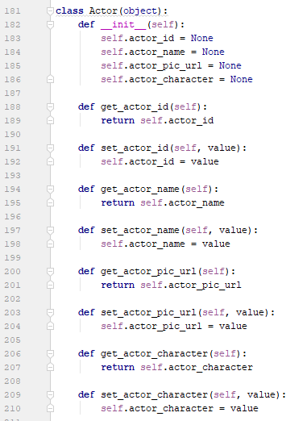

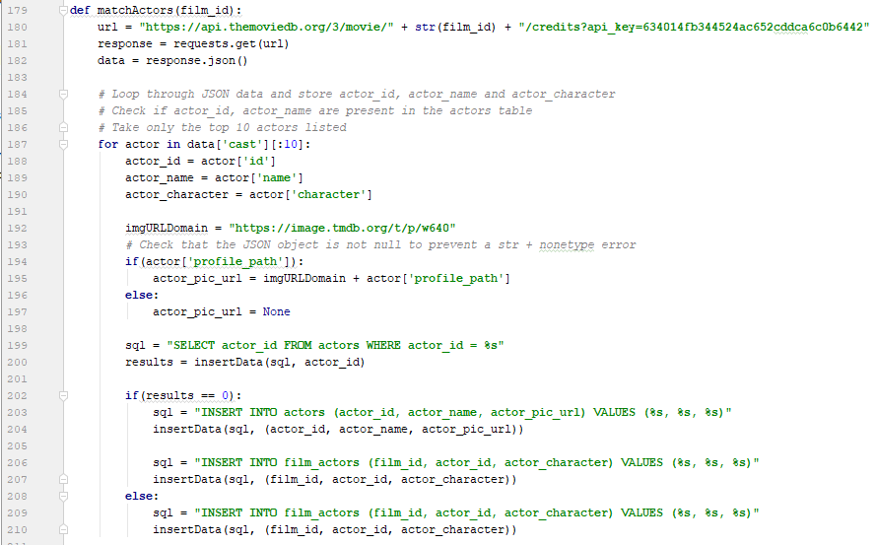

* 1 class per database table
* 5 separate SQL queries
* Map results to an object
* 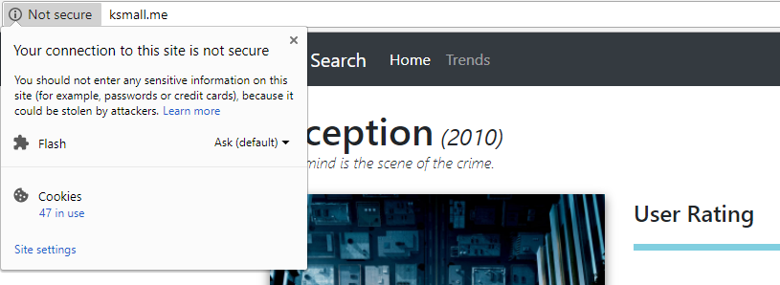Return jsonpickled object

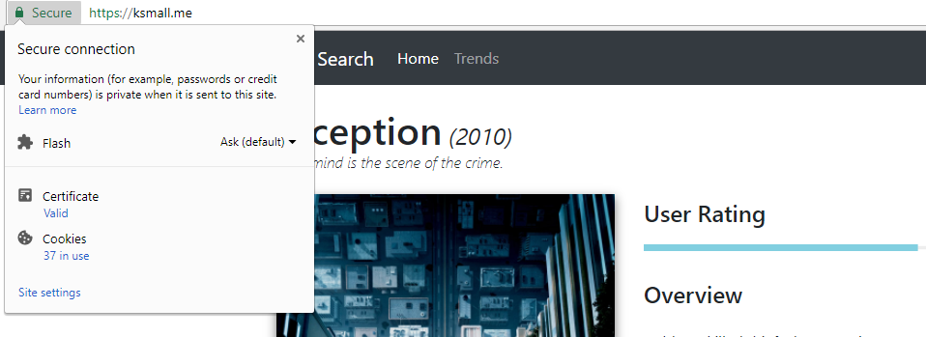

# Testing Verification and Validation

## Unit testing

Unit testing is a method that involves testing the individual components of an application, such as functions, classes and so on, to ensure that they carry out their intended purpose (ISTQB Exam Certification, 2018). This project however, did not conduct any automated unit testing with specialist testing software, instead the unit tests were carried out manually. This involved utilising Python’s *print* function, which provides a full traceback detailing where exactly an exception has been raised and this helps identity and locate the erroneous code as quickly as possible. A collection of the vital unit tests carried out are provided below inTable 1.

**Back-end code (Data acquisition)**

|  |  |  |  |  |
| --- | --- | --- | --- | --- |
| Test ID | Component | Expected Outcome | Actual Outcome | Action Taken |
| 1 | getLatestFilmID() function | Retrieves the latest ID from TMDb API | The latest film ID is returned from TMBd API | None |
| 2 | insertData() function | Takes 2 parameters, a SQL query and the values being inserted into the database, queries the database and returns the results | Inserts the data passed and returns the results of the execution when called | None |
| 3 | selectData() function | Takes a SQL query and selects data from the database, returning the results | Selects data from the database and returns the results | None |
| 4 | insertGenres() function | Fetches a list of genres and inserts them into the database | Fetched genres are successfully inserted into the database | None |
| 5 | getTrailerData() function | Takes in a film id, queries TMDb API for a YouTube video key, queries the YouTube API with that key and returns all trailer details related to the key | Returns the trailer URL, view, like and dislike counts as expected | None |
| 6 | matchGenres() function | Checks to make sure if genres related to the current film iteration are already in the genres table, if they aren’t add them and if they are do not | Adds genres to the genres table if not present, otherwise updates the association table with the genres for the current film iteration | None |
| 7 | matchProdComps() function | Checks to make sure if production companies related to the current film iteration are already in the production companies table, if they aren’t add them and if they are do not | Adds production companies to the production companies table if not present, otherwise updates the association table with the production companies for the current film iteration | None |
| 8 | matchActors() function | Checks to make sure if actors related to the current film iteration are already in the actors table, if they aren’t add them and if they are do not | Adds actors to the actors table if not present, otherwise updates the association table with the actors for the current film iteration | None |
| 9 | matchDirectors() function | Checks to make sure if directors related to the current film iteration are already in the directors table, if they aren’t add them and if they are do not | Adds directors to the directors table if not present, otherwise updates the association table with the directors for the current film iteration | None |
| 10 | checkIfPresent() function | Simply performs a check to see if the data being passed to it is there or not, if it is return the data, if it isn’t return *None* | Returns the data if present, returns *None* if it isn’t | None |
| 11 | insertFilms() function | The main function that runs via a while loop across a list of all film ids and acquires all of the film metadata utilising each function listed above and stores the data in the database | Executes via a while loop, displays a progressbar, sleeps to avoid exceeding rate limitations, filters out adult and foreign films, prints any errors to a csv file | None |

Table 1 - Back-end code (Data acquisition) unit test results

**Back-end code (Regression modelling and predictions)**

|  |  |  |  |  |
| --- | --- | --- | --- | --- |
| Test ID | Component | Expected Outcome | Actual Outcome | Action Taken |
| 1 | Training data mapping | Training data csv is mapped correctly to a pandas dataframe structure | A pandas dataframe is created, populated with the csv data and with the relevant header names | None |
| 2 | Genre categories mapping | Genre categories are read from a csv file and mapped to a Python dictionary object | Genre categories successfully stored in Python dictionary | None |
| 3 | Film genres acquisition | A list of genres for each film are acquired, using the genre categories dictionary as a reference | List of genres for each film are successfully acquired and stored in a list | None |
| 4 | One-hot encoding genres | Genres are subjected to a formatting technique called one-hot encoding | Each genre is given its own category and a binary value represents a genres relation to a certain film | None |
| 5 | Handling NULL values | NULL values are imputed using the *fillna* function within pandas | All NULL values are replaced with an arbitrary -1 value | None |
| 6 | PCA | The dataset is subjected to PCA, which reduces the number of dimensions | The number of dimensions are reduced successful and the results and the target are appended back into a single dataframe | None |
| 7 | Regression fit | The formatted dataframe is fitted to the decision tree regressor | The decision tree regressor is trained successfully | None |
| 8 | Saving the model | The model is then saved to an external file, so that it can be loaded at any point | Model is saved to an external file successfully | None |
| 9 | Regressor predictions | The regressor makes predictions on the test data | Predictions on test data are stored successfully in a list | None |
| 10 | Storing prediction ratings | Predicted ratings are inserted into the database | Predicted ratings are successfully stored in the database | None |
| 11 | Regression metrics | The explained variance and mean absolute error values are printed to the console | Regression metrics are successfully printed to the console | None |

Table 2 - Back-end code (Regression modelling and predictions) unit test results

**Front-end code (API routing)**

|  |  |  |  |  |
| --- | --- | --- | --- | --- |
| Test ID | Component | Expected Outcome | Actual Outcome | Action Taken |
| 1 | Genre() class | The required variables are created and the appropriate setters and getters are created | Class created to store genre data as objects | None |
| 2 | Actor() class | The required variables are created and the appropriate setters and getters are created | Class created to store actor data as objects | None |
| 3 | Director() class | The required variables are created and the appropriate setters and getters are created | Class created to store director data as objects | None |
| 4 | Production_Company() class | The required variables are created and the appropriate setters and getters are created | Class created to store production company data as objects | None |
| 5 | Film() class | The required variables are created and the appropriate setters and getters are created, including instances of the genre, actor, director and production company classes as lists | Class created to store film data as objects | None |
| 6 | Trends() class | The required variables are created and the appropriate setters and getters are created | Class created to store trend data as objects | None |
| 7 | index route (“/”) | The home route that simply returns the index.html template | Route directs users to the index.html template page | None |
| 8 | trends route (“/trends”) | The home route that simply returns the trends.html template | Route directs users to the trends.html template page | None |
| 9 | getTrends route (“/api/get_trends/<int:trend_id>”) | The route that queries the database, maps the returned data to the trends object and stores the data into a json file | Queries database for trends, maps results to trend object, saves object to json file | None |
| 10 | getTrends route (“/api/show_trends/<int:trend_id>”) | The route that loads a trend json file by the provided id and returns the results to the page as an HTTP response | Returns loaded json data to the page as an HTTP response | None |
| 11 | getFilms route (“/api/search/films”) | The route responsible for taking in an additional query parameter and querying the results returned from the database, returning an HTTP json response | Uses query parameter in SQL query, returns an HTTP json response with the results | None |
| 12 | getFilm route (“/api/film/<int:film_id>”) | The route takes a single film id and queries the database for the required metadata | Returns an HTTP json response with the metadata related to that single film id | None |

Table 3 - Front-end code (API routing) unit test results

**Front-end code (HTML/CSS/JS)**

|  |  |  |  |  |
| --- | --- | --- | --- | --- |
| Test ID | Component | Expected Outcome | Actual Outcome | Action Taken |
| 1 | Navigation links function as intended upon user selection | User relocated to alternate page | Alternate page loads | None |
| 2 | Navbar menu dropdown button toggles on smaller devices when clicked | Toggled button reveals dropdown menu | Nothing happens when selected | See section 7.1 |
| 3 | Input field produces results when a query is provided | A list of (up to 10) results are displayed to the user | Results are displayed to the user | None |
| 4 | Selecting an item from the search results updates the page content | Film data should update dynamically | Film data is updated dynamically | None |
| 5 | YouTube video trailer is playable | The YouTube video should be playable | The YouTube video can be played | None |
| 6 | YouTube controls are accessible/usable | All of the default YouTube controls should be visible and usable by the user | The user can see and select any of the default YouTube controls | None |
| 7 | Trend graphs display data to the user upon page load | When the user visits the trends page, the graphs should load | Upon visiting the trends page the trend graphs load immediately | None |
| 8 | The trend graphs should display additional data when hovered over | If a user hovers over the trend graph additional data should be displayed | When the user hovers over the trend graph additional data is displayed | None |
| 9 |  |  |  |  |

Table 4 - Front-end code (HTML/CSS/JS) unit test results

## Compatibility testing

It is always essential to test any web application on a variety of operating systems, devices and browsers, to ensure that it reaches and is accessible to the widest range of users. Due to the nature of the project, the front-end interface is the platform in which users will interact with, therefore only this part of the application has been compatibility tested and the prediction modelling has not. At the time of writing this, the most up-to-date versions of the operating systems and browsers were used for each individual test.

|  |  |  |  |  |
| --- | --- | --- | --- | --- |
| Test ID | Device | Operating System | Web Browser | Pass/Fail |
| 1 | Desktop | Windows 10 | Google Chrome | Pass |
| 2 | Desktop | Windows 10 | Mozilla Firefox Quantum | Pass |
| 3 | Desktop | Windows 10 | Microsoft Edge | Pass |
| 4 | Desktop | Windows 10 | Internet Explorer 11 | Fail |
| 5 | Laptop | macOS High Sierra | Safari | Pass |
| 6 | Laptop | macOS High Sierra | Google Chrome | Pass |
| 7 | Laptop | macOS High Sierra | Mozilla Firefox | Pass |
| 8 | Mobile | Android 8.0 “Oreo” | Google Chrome | Pass |
| 9 | Mobile | Android 8.0 “Oreo” | Mozilla Firefox Focus | Pass |
| 10 | Mobile | iOS 11 | Safari | Pass |
| 11 | Mobile | iOS 11 | Google Chrome | Pass |

Table 5 - Application compatibility test results

*Table 3* clearly identifies that almost every compatibility test passed, but happens to fail when tested on a Windows 10 desktop device running Internet Explorer 11. This test result was inspected further and the results are discussed in section 7.1.

## Usability testing

Usability testing revolves around making sure that the user experience when performing tasks using an application is an easy and problem-free process. Therefore, the following set of tests outlined in *Table 4* reveal the results of two external users that the developer knew and asked to test the application.

|  |  |  |  |  |
| --- | --- | --- | --- | --- |
| Test ID | Description | Pass/Fail | | Action Taken |
| **User 1** | **User 2** |
| 1 | Can you search for a film using the search input field? | Pass | Pass | None |
| 2 | Can you play the YouTube video trailer loaded for a film? | Pass | Pass | None |
| 3 | Can you full screen the YouTube video trailer loaded for a film? | Pass | Pass | None |
| 4 | Can you locate a film of your choice via the search input field with ease? | Pass | Fail | See section 7.1 |
| 5 | Can you hover over the trend graphs to display additional information? | Pass | Pass | None |
| 6 | Can you load a film within a reasonable amount of time? | Pass | Fail | See section 7.1 |
| 7 | Is the site easily accessible via the URL provided? | Pass | Pass | See section 7.1 |

Table 6 - Front-end application usability test results

The results from the usability tests were fairly reasonable, with only two failures relating mainly to the querying of films. The outcome of these tests and how they were resolved are covered in detail in section 7.1.

## Regression metrics

For a regression algorithm, there are a few metrics that can be used to gather information relating to how accurate the model that has been trained is. The two metrics that were used for this project were, explained variance and mean absolute error.

The explained variance metric helps identify how spread apart are the prediction results from their mean value. So, a regression model like the decision tree regressor essentially looks for the inter-linking relationships between the independent variables (the features used to train the model) and the dependant variable (the target value that is being predicted). The closer the value is to 1, the more accurate the model should be. There are however other factors that can affect a model’s explained variance.

The mean absolute error on the other hand, is the average spread of errors from the dataset, the differences between the actual results and the prediction results. If these values were to be plotted on a graph whereby the X values were the actual (true) results and the Y values were the prediction results, in machine learning the mean is usually represented by 0. So, imagine a straight-line being drawn where both X and Y = 0, the prediction values closer to that line illustrate a higher level of accuracy as the mean spread of errors will be lower. A MAE that is negative (below the mean) reveals an underestimation in the predicted values, whereas a positive MAE represents an overestimation in the predicted values.

|  |  |  |  |  |  |
| --- | --- | --- | --- | --- | --- |
| Test ID | Regression Metric | Result | Training Data Used | Additional Regressor Parameters | Action Taken |
| 1 | Explained variance | 0.1535 | All training data | max_depth = 2 | Retrain |
| 2 | Explained variance | 0.0512 | All training data, with NULL values ignored | max_depth = 2 | Retrain |
| 3 | Explained variance | -0.5685 | All training data | max_depth not set | None |
| 4 | Mean Absolute Error | 32.3410 | All training data | max_depth not set | None |

Table 7 - Regression metric results table

Both metrics assisted with helping the developer better understand the accuracy of the model that had been trained and from Table 7, it is evident that the model is overestimating the prediction values and that a lot of work needs to be carried out in improving the overall accuracy of the model. The details of the accuracy predictions are discussed in section 7.2.

## Testing limitations

# Discussion

The discussion section follows on naturally from the results presented in the previous section. The discussion is usually substantial and is where you discuss your test results in detail, and their implications, and also potentially make links to relevant previous work. Analyse the success of your solution. Discuss limitations of this project, which will help when you introduce your Future Improvements in the Conclusion section. Reflect also your learning experience, e.g. what you will do differently if you would do this project again.

## Known issues

The testing that was conducted as part of section 6, exposed some important features of the application that needed improving, mainly to do with the usability of the application.

|  |  |  |  |
| --- | --- | --- | --- |
| Reference ID | Description | Priority | Action |
| 1 (Unit – Front-end) | On mobile devices, the navigation menu reduces to a togglable button, but this was not functioning as intended | High | Completed |
| 4 (Compatibility) | Display of film data and input field functionality not functioning on Windows 10 Desktops using Internet Explorer 11 | Low | To do |
| 4 (Usability) | Difficult to locate certain films using the input field | Medium | Completed |
| 6 (Usability) | Initial loading of the search results and autocomplete/suggestion features are sometimes slow | Low | Completed |
| 7 (Usability) | The site does not have secure communication via HTTPS | High | Completed |

Table 8 - Known issues table

When it came to correcting the issues referenced in *Table 5* above, the higher priority tasks were resolved first. This is because, these issues are more likely to result in missing or reduced application functionality or potential security risks.

To begin with, the first issue related to being able to access the menu items (home/trend page links and search bar) on mobile devices. On mobile devices, the menu button that is supposed to toggle when click and reveal the navigation items and search bar was not functioning. This is a major problem, as it prevents mobile users from being able to use the application for its intended purpose. To rectify the issue however, was an extremely easy fix. It was a matter of making sure that the *div* element containing the menu items had an id value that matched the *data-target­* element attached to the togglable button.

Upon configuring the Flask application on a DigitalOcean droplet, a valid certificate had not been acquired from a Certificate Authority (CA) at that time. However, there are plenty of sources that offer free certificates, the most notable being Let’s Encrypt (Let's Encrypt, 2018). As this application does have shell access to the server over SSH, an automated certificate issuance and installation tool can be used called Certbot (Certbot, 2018). The instructions are straight forward to follow and allowed for an extremely smooth installation process.

Figure 1 below illustrates a selection of the type of questions that were asked during the setup and installation process. Most notably the last question, which asks whether or not all HTTP traffic should be redirected to HTTPS, removing HTTP access as a result. Option 2 was selected and this was for two reasons. The first being that, HTTPS access is more secure and should be used across the web. In July 2018, Chrome will be one of the first browsers to mark non-HTTP as *not secure* with the release of Chrome 68 (Google, 2018). The second reason behind implementing HTTPS access is due to the way in which in the API handles credentials that are used to connect to the database. When passed in plaintext and using an HTTP connection, the credentials would be readily available for any experienced hacker to grab them in transit. However, by implementing an HTTPS connection and forcing all users to do the same, it is not possible to access the credentials in transit thus implementing basic API authentication.

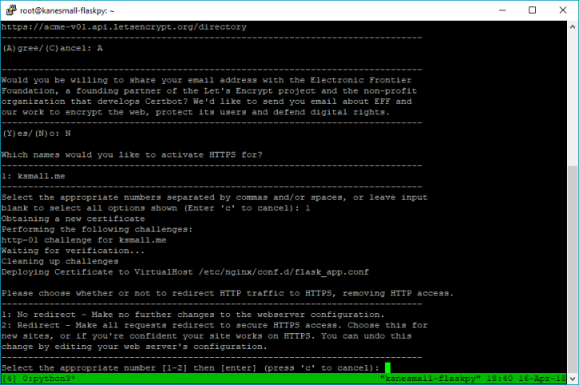Figure 1 - Certbot installation via PuTTY

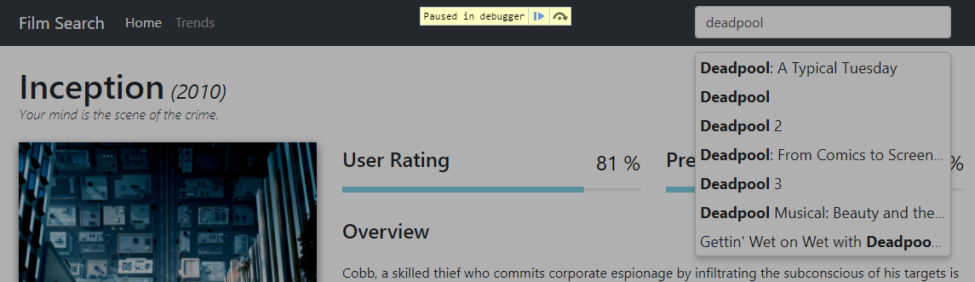Next up was the issue relating to locating certain films using the input field. The user who marked this usability test as a fail informed the developer that this was due to the way in which the results were returned after a query had been entered making it difficult to locate certain films. To rectify this issue, additional film metadata was added to the query results so that users could better pinpoint films with similar titles, or films with the same name due to a rebooting of the series for example. This is illustrated by the comparison of Figure 2 and Figure 3.

Figure 2 - Query results (old)

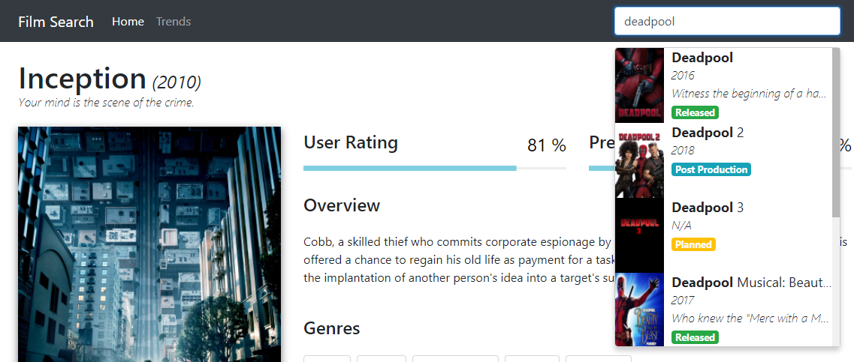Figure 3 - Query results (new)

Next, the issue relating to the load time of the query results which was only documented by one of the users as a fail. The user in question stated to the developer that it was not an issue all of the time, but did occur on a rather regular basis. They also mentioned that the load times were already more than reasonable, but that an increase in speed would result in a much more fluid experience for the user.

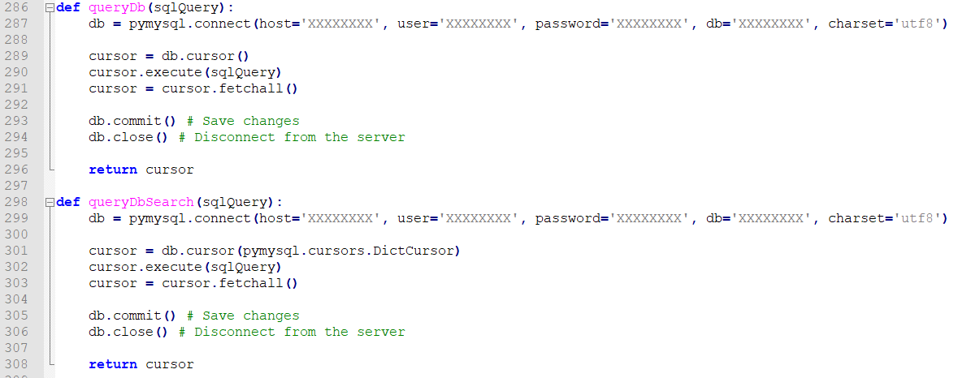This issue required a bit more attention than the last, mainly due to the way in which the search results were queried via the API. But after a bit of research, a pymysql has a class (pymysql.cursors.DictCursor) that can be passed to the *cursor()* object as a parameter allowing the cursor to return the results as a python dictionary (pymysql.readthedocs, 2018).

Figure 4 - Database query function comparison

As illustrated by Figure 4 above, by duplicating the already existing database connection function and altering the cursor parameters, it would now be possible to utilise this function within the correct API route. Now, as part of the */api/search/films* route, because the *queryDbSearch()* function will now return a python dictionary of results, this can simply be serialised using jsonpickle and returned as a response to the web page. As evident in Figure 5, the code that has been commented out was responsible for mapping each element returned from the SQL query to a python class. This was the part of the code that was rather expensive and was causing slow load times for the query results.

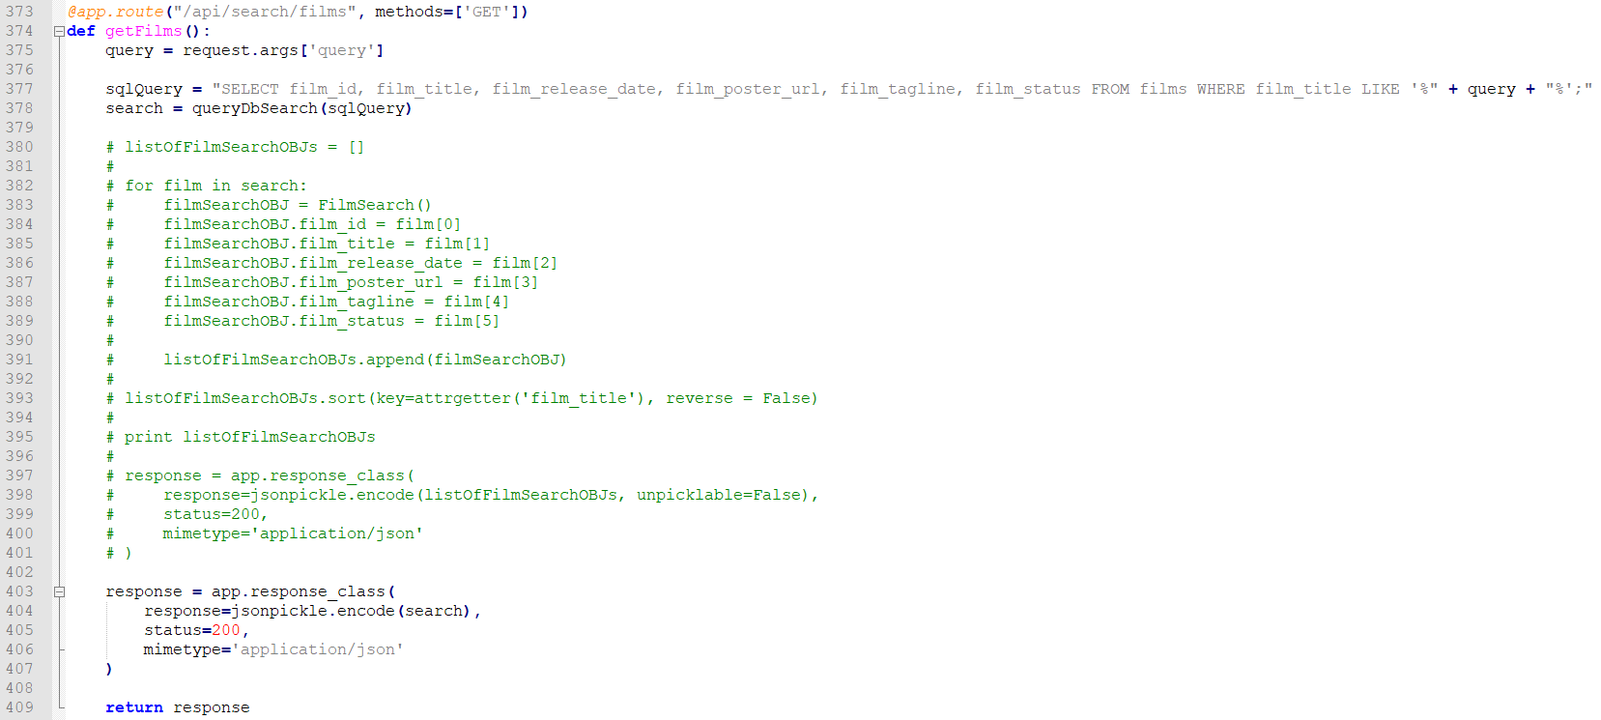Lastly, there is the issue relating to the displaying of data and input field querying not functioning as intended whilst using a Windows 10 desktop running Internet Explorer 11. From a cursory overview within Internet Explorer 11 using the in-built developer tools, it appeared that the *progressbar.js* library being utilised to display the animated user and predicted rating progress bars, is not supported for the Internet Explorer 11 browser. Due to the fact that it would have taken a while to locate a replacement library for generating animated progress bars that was compatible with Internet Explorer, this issue has been left with the status of *To do*. It was also more important to ensure that support/compatibility for the most popular browsers was the main priority and as can be seen on *statcounter* (statcounter, 2018), Internet Explorer is only used by 3.13% of total users, whereas Chrome, Safari and Firefox total of 77.88% of users worldwide.

Figure 5 - /api/search/films route

## Prediction accuracy

The results shown are difficult to make assumptions on by themselves, but it is clear that the model trained isn’t exceedingly accurate and does overestimate the prediction values. This could be a result of a number of factors and when it comes to machine learning in general, there are so many factors to consider that may have influenced the end results.

**Model selection**

When it comes to selecting the appropriate model for a particular dataset, there isn’t necessarily a full proof method, lots of different variables affect the decision. Scikit-learn provide a *cheat sheet* (Appendix 4: Scikit-learn algorithm cheat sheet), which can be used as a starting point for understanding which types are better suited toward specific datasets. However, this should not be the only tool used when selecting a model.

Even today, one of the best approaches to selecting the best model for your dataset is trial and error (Sief, 2018). Implementing, training and then comparing the prediction accuracy results of each will give a better understanding of the factors that improve accuracy. But, due to time constraints, training different models was simply not possible considering how long it takes to do just that.

That is why, in the future it would be best to try implementing different models and continually attempting to improve feature selection and pre-processing techniques to learn which methods and which combination of methods, result in the most accurate results. A potential neural network solution could even be something to consider, as they are exceedingly effective at modelling highly complex non-linear relationships (Sief, 2018) and that is what this dataset has a lot of. More details on the future improvements that have been considered however, can be found in section 11.1.

**Feature selection**

Another reason for the results attained could simply be a consequence of the features that have been selected. The features, budget, runtime, trailer view/like/dislike counts and user rating, might just not have been the right attributes for making predictions on the user ratings. Given more time and a better understanding of feature selection and pre-processing, the model would have also been trained using additional metadata values as features such as, actors, directors, production companies and other film-related attributes that were not acquired for this project. Again, more information on additional feature selection can be found in sections 11.4 and 11.7.

**Summary**

Ultimately, this isn’t the end of the project even after submission. There are a variety of additional methods to try, new features to acquire and use to train models and even entirely different machine learning solutions to learn about. The main objective of, implementing a regression algorithm to train a model that could make predictions on previously unseen data has been accomplished. It is now the responsibility of the developer to improve the accuracy of those predictions over time, utilising the infrastructure that has been developed over the course of this projects lifetime.

## Application limitations

There are definitely still limitations related to this application, primarily with the absence of interactivity whereby users can create custom search parameters in order to receive a prediction output. But, one could argue that this was never the intended purpose of the project and is simply an idea that has presented itself over the course and nearer to the end of the project’s lifetime. Section 11 addresses in detail, a number of improvements that could be made given more time and if the project were to be continued even after university.

# Reflection

As a final year student completing his/her degree, you are required to undertake a final year project that must be completed throughout the last year and alongside other pieces of coursework. I will be looking at how I personally felt at each point during the project’s lifetime and ultimately, what I learned from this experience and how I could improve if given a second chance.

My initial feelings for the project were ambivalent, mainly due to the sheer size of the undertaking and because we had to continually work on the project throughout the year alongside multiple pieces of coursework being set by each module lecturer. However, once I had settled on a project idea and started working on it, because I was working on something that I find of interest to me I think this helped in viewing the project as an enjoyable set of tasks as opposed to mandatory *work*.

One of the worst parts of the project for me was before the year had even started. A few months before beginning our final year, we were tasked with either selecting a pre-defined project from a list that was provided or coming up with our own idea and submitting a PID for it. For my placement I worked at a cyber security company and so for the best part of that year I had been thinking of cyber security related projects that could have been interesting to complete. However, I eventually decided that cyber security was no longer a field I wished to pursue, as I wasn’t enjoying it as much as I was in the beginning. Therefore, completing a project related to that field no longer made sense. So, this left me with a few weeks of having to think of an entirely new project.

The stress and anxiety that the final year project caused me was severe and at times, very overwhelming. Having to juggle separate pieces of coursework for different modules I found challenging enough in the first two years of university, but having this additional project weighing down on you and also knowing that it’s worth a third of the entire year in terms of marks was again, at times too much to handle.

That being said, I have learned with the help of my incredible Mother, certain coping techniques and strategies to alleviate some of the pressures of work similar to this. So, there were definitely good experiences that I had whilst completing my project. I thoroughly enjoyed improving my programming ability with every piece of code I had to write. I decided to build my application in Python, because I believe that I have the most experience with this language over any other that I have used in the past, yet after having completed this project I feel as if I’ve learned so much more about the language then I could have imagined.

Learning how to implement machine learning has been a very interesting journey. I didn’t quite anticipate the level of difficulty that using these tools would provide but learning how to implement them as well as *why* to implement a specific algorithm for example has been really enjoyable. I have only just touched the surface when it comes to machine learning but, with so many industries beginning to adopt this technology it could be a very interesting field to break into after university.

In conclusion, from my experience I now know that it is vital to carry out research first and at the earliest point in development as possible. Before you can tackle any task, you need to have all of the tools, including the knowledge of how to implement *with* those tools.

Looking at my personal experiences and my unique style of working I would say that, industry experts spend months and months, sometimes even years, attempting to perfect machine learning models. I can’t expect to have achieved outstanding results on my first attempt and that shouldn’t hinder me from trying to get better results, trying different models and comparing accuracy scores. Just because this is the end of my project from an academic-perspective doesn’t mean it *has* to be the end of my journey of continuing to expand my knowledge in this vast field.

I think, if I were to undertake this or a similar project again I would try to focus on asking more questions. Making sure that I came prepared to each supervisor meeting with detailed questions, where we could then have discussions about. I would also ensure to utilise strategies to help me, such as recording feedback my supervisor gives me so that I don’t forget what has been said by the time I get home. I need to focus on my worst qualities first next time, such as time management and organisation. If I create a plan of action of *how* I am going to tackle these obstructions, it will be easier when it comes to starting.

# Social, Legal, Health and Safety and Ethical Issues

## Social, legal and ethical issues

When constructing the PID initially no social, legal or ethical issues were identified. However, upon reflection there are a couple of social and ethical issues that could in fact relate to this project.

Firstly, one of the social issues concerning the usage of the application itself relates to users who speak another native language other than English and would therefore not be able to understand the content that is being displayed to them. A simple solution to this problem would be to implement some form of translation feature, possibly with the help of an existing library that supports hundreds of languages and give the user the option to change the language manually. However, a more streamlined approach would be to automatically detect the user’s location via their browser session and to convert the language for them. But, having the manual option present would still be required for users that are visiting the application whilst using a VPN.

Secondly, an additional social issue which again, concerns the usage of the application itself, would be the fact that the application does not cater toward users with disabilities such as visual impairments. There are a variety of solutions of for this type of issue including but not limited to, ensuring that all *<img>* tags are making proper use of the ‘alt’ tag that describes what an image (often used for screen readers), ensuring that the web application is fully-operable via *­just* the keyboard, providing users with the control over text sizing for all elements and having an option for users to be able to alter the contrast levels of the application or include specific colour-blindness modes.

Finally, an ethical implication of this project could be that if the prediction accuracy of the ratings was high enough some could argue that there would no longer be a need for film critics, thus putting a lot of people out of work. A second ethical issue, that follows on closely from the last relates to the emotional side of films. A lot of people believe that computers are not capable of replicating human emotion and therefore, they will never be as accurate as a human critic. There are often films that do draw heavily on a viewer’s emotion, regardless of the known variables such as the genres, budget, trailer view count, etc and therefore it is hard to envisage a scenario in which a computer would consider these parameters when formulating predictions. Such film’s that are considered *cult-classics* would also be extremely difficult to predict accurately for, since a lot of the time these films are liked by viewers regardless of critic ratings/reviews, or factual metadata such as the actors in the film.

## Health and safety risks

There were a few risks that were identified during the creation of the PID relating to the work area and these were eye strain, hardware failure and repetitive strain injury. Eye strain was reduced by taking regular breaks and by utilising an application call *f.lux* (f.lux, 2018), which reduces blue light exposure. To reduce the risk of hardware failure, all documents and code were backed up to a private GitHub repository as well as Google Drive. Lastly, the risk of repetitive strain injury was reduced by taking regular breaks, using an ergonomic chair with lumbar support and height adjustments and by simply adjusting the workstation to appropriately conform to the user’s requirements.

# Conclusion

#### Briefly restate the project objectives and then make straightforward conclusions about your project work and results. What have been the key outcomes? You can suggest future work that logically stems from your work and refers to the limitations of your own work in the Discussion section.

Data acquisition, data cleansing/pre-processing, regression modelling and predictions, API routing and front-end design and user experience.

As a final point,

# Future Improvements

A lot of time and thought has gone into how this project could be improved if more time had been allocated, or simply as the project continues to grow past a university project.

## Improving prediction model accuracy

One of the most important considerations is improving the accuracy of the prediction model. This is the core feature of the application and being able to specify to your users that this application is capable of predicting user ratings for unreleased films, to certain high-level degree of accuracy, would encourage a lot more people to use the platform.

In machine learning it is common practice to implement multiple algorithms to see which is best suited toward your specific dataset. So, with more time it would be possible to train different models and compare the accuracy scores (explained variance, MAE) of each to see which is the most precise at predicting user ratings.

## TV show support

Implementing TV show support as well as film, would allow for the application to have a lot more range and to appeal to a wider audience. The Movie Database API (The Movie Database, 2018) already allows developers to retrieve metadata for TV shows, so by utilising the same scripts that have already been created for the film data acquisition and altering them slightly all TV show metadata could be acquired.

## Additional trend graphs

It would be advantageous to provide the user with additional trend graphs via the *trends* page, but also allow for more user interactivity by having some form of filtering option available on the existing and any future graphs. An added interactive feature could include the option to search for a specific production company for example and to show a variety of trend analytics specifically for that search query.

## External ratings

Requesting ratings from other external sources such as Rotten Tomatoes and/or Metacritic would not only allow users to see all ratings for a film in a singular location but could also help influence prediction models by providing these specific ratings as additional features. Rotten Tomatoes for example, has a *want-to see list*, which indicates how many users have added an unreleased film to their want-to see list. So, utilising this feature could help increase the accuracy of the model by revealing the percentage of users that are already interested in seeing the film.

A similar idea could be applied to both Twitter and Facebook pages whereby, users can follow or like pages that have been created for upcoming films. But, this could be taken a step further and tweets and/or Facebook comments could be analysed using sentiment analysis to determine whether the content is positive or negative and again used as additional features for training the model.

## Updater function

This is an important function to have for an application like this one, whereby on a set schedule (once a week, or once a month) a function would trigger that would be responsible for looking at all existing data in the database and comparing it against The Movie Database API to see if any new films have been added, but more importantly to check if any existing films have been updated or altered in anyway. If a film’s metadata has changed, then the function will retrieve the new data and replace the old data in the database.

Once updated or additional data has been acquired, the function will then be responsible for re-training the model to account for the new data. This will ensure that as new data enters the system, all prediction rating values are also updated to better reflect any changes in the relationships that the model had previously been trained on.

## Targeting businesses

By adding additional functionality to the application whereby allowing users to configure their own custom test cases for unreleased films, this application could be targeted toward production companies. These industry experts are always trying to find the *winning* formula for a film and one that will generate the highest amount of revenue. If they had the ability to compute different combinations of variables such as, which actors, or which director would best suit an upcoming film based on the predicted rating output, then it would be extremely beneficial and lucrative for them.

## Oscar nominees and winners

A very interesting model feature was considered toward the end of the project and as such, has been constructed into a future improvement. The idea centred around utilising Oscar nomination, winner and potentially other film award or accolade data, as an additional feature when training the model; which could have a huge advantage on the outcome of the prediction values. It would work so that, whenever a film is either nominated or wins, a unique category would then be populated for each attribute of the film. Taking this year’s Academy Awards for example, Blade Runner 2049 won an Oscar in best visual effects category (Donnelly, 2018). So, each film attribute, the genres, the actors, the director, the production company and so on; would also receive numerical value appended onto this unique category mentioned above. Each value could also be weighted differently depending on the category in which it has originated from and depending on whether the end result was simply a nomination or an actual win.

# References

Donnelly, J., 2018. *Oscar Winners 2018: See the Full list.* [Online]   
Available at: http://oscar.go.com/news/2018/oscar-winners-2018-see-the-full-list

f.lux, 2018. *justgetflux.* [Online]   
Available at: https://justgetflux.com/

Sas.com, 2018. *Machine Learning - What it is and why it matters.* [Online]   
Available at: https://www.sas.com/en_gb/insights/analytics/machine-learning.html

The Movie Database, 2018. *Get TV Details API Documentation.* [Online]   
Available at: https://developers.themoviedb.org/3/tv/get-tv-details

# Appendices

## Appendix 1: Project Initiation Document

## Appendix 2: Logbook

## Appendix 3: Questionnaire

## Move mouse over imageAppendix 4: Scikit-learn algorithm cheat sheet